**Mid Term Exam**

**Course: Digital Marketing (DIM)**

Answer no. 1: **Facebook Page Setup for Business**

### **1. Log in to Facebook**

* Use your personal Facebook account to create the business page. If you don't have a Facebook account, you'll need to sign up for one first.

### **2. Choose a Page Type**

You’ll be prompted to select a category for your page:

* **Business or Brand**: Ideal for promoting your company, products, or services.
* **Community or Public Figure**: For organizations, public figures, or groups.

Click **Get Started** under "Business or Brand."

### **3. Add Page Information**

Fill out the required details:

* **Page Name**: Use your business name or a name that reflects your brand.
* **Category**: Start typing keywords (e.g., “Restaurant,” “Consulting Agency”) and select the most relevant option.
* Click **Continue** to proceed.

### **4. Upload Your Profile Picture**

* Choose an image that represents your business, like a logo.
* Dimensions: **170 x 170 pixels** for desktop display.
* Click **Upload Profile Picture** and choose your file.

### **5. Upload Your Cover Photo**

* Add a visually appealing image for your page’s header. This could be your storefront, a promotional graphic, or something representing your services.
* Dimensions: **820 x 312 pixels** for desktop and **640 x 360 pixels** for mobile.
* Click **Upload Cover Photo** to upload your image.

### **6. Customize Your Page**

* **Add a Description**: Write a short intro about your business (up to 255 characters).
* **Contact Information**: Add a phone number, email, or website.
* **Location**: Enter your business address (if applicable).
* **Hours of Operation**: Specify your working hours if your business has fixed timings.
* Save your changes.

### **7. Create a Username**

* A username (e.g., @YourBusinessName) makes it easier for people to find your page.
* Click **Create @Username** on your page’s homepage.
* Choose a unique and recognizable username (limit: 50 characters).

### **8. Add a Call-to-Action Button**

* Click the **Add a Button** option below your cover photo.
* Choose an action like “Contact Us,” “Book Now,” or “Learn More,” depending on your business.
* Link it to your website, booking system, or preferred contact method.

### **9. Complete the Page Settings**

Go to the **Settings** tab to:

* **Enable Messaging**: Allow customers to contact you via Messenger.
* **Page Roles**: Add admins or team members who can manage the page.
* **Privacy Settings**: Adjust who can see your page or post on it.

### **10. Post Content**

* Create an introductory post to welcome visitors to your page.
* Share engaging content like photos, videos, updates, or offers.

### **11. Promote Your Page**

* **Invite Friends**: Click the “Invite Friends” button to share your page with your personal network.
* **Boost Posts or Ads**: Use Facebook Ads to target a larger audience.
* Share your page link on other platforms or email newsletters.

### **12. Monitor and Optimize**

* Use the **Insights** tab to track page performance, audience demographics, and post engagement.
* Adjust your strategy based on data to improve results.

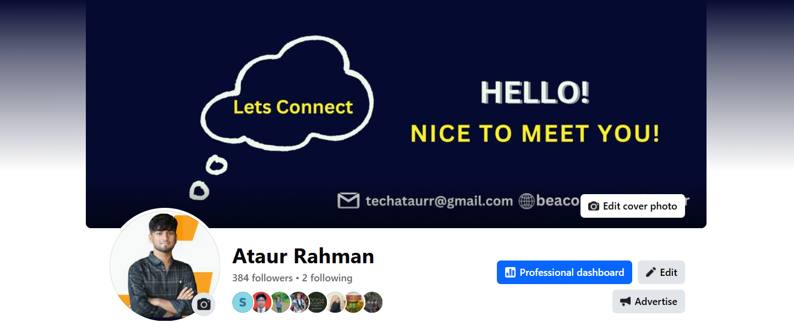

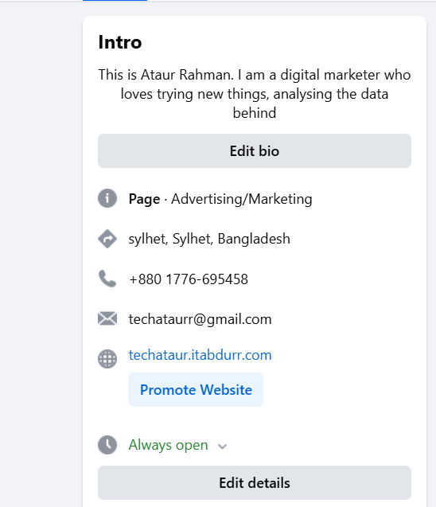

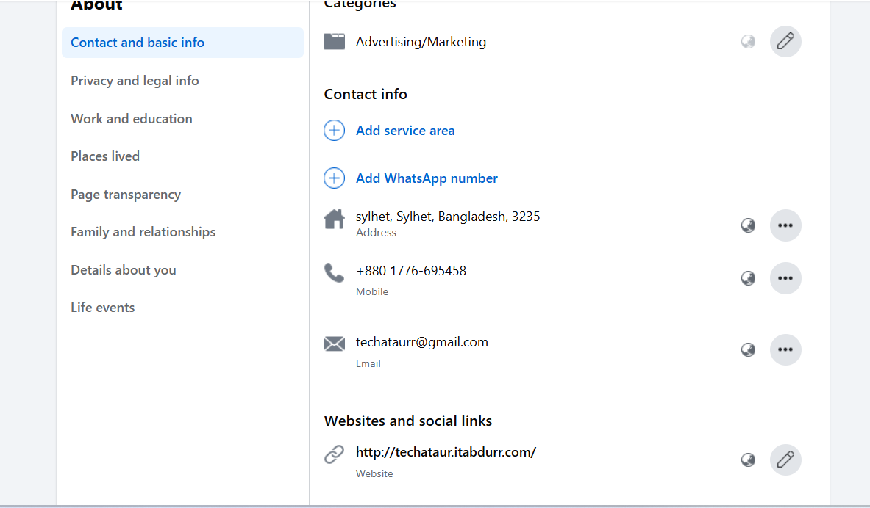

**Answer no.2: Youtube Channel Creation And Optimization**

## **1. Sign In to YouTube**

* Log in with your Google account. If you don’t have one, create a new Google account.

## **2. Create a YouTube Channel**

1. **Access Channel Settings**:
   * Click your profile picture in the top-right corner.
   * Select **“Create a channel”**.
2. **Choose a Name**:
   * You can use your personal name or create a custom name for your channel.
   * If creating a brand or business channel, select **"Use a custom name"**.
3. **Complete the Setup**:
   * Follow the on-screen instructions to create your channel.

## **3. Customize Your Channel**

* Go to your channel homepage and click **“Customize Channel”** in **YouTube Studio**.

### **Channel Layout:**

* Add sections like "Popular Uploads," "Playlists," or "Recent Videos" for better navigation.

### **Channel Branding:**

1. **Profile Picture**:
   * Use a high-quality image (e.g., logo or personal photo).
   * Recommended dimensions: **800 x 800 pixels**.
2. **Banner Image**:
   * Add a visually engaging banner to represent your brand.
   * Recommended dimensions: **2560 x 1440 pixels** (safe area: 1546 x 423 pixels).
3. **Watermark**:
   * Add a small logo or branding icon to appear on your videos.
   * Dimensions: **150 x 150 pixels**.

### **Basic Info:**

* **Channel Description**:
  + Write a short, clear description about your content, target audience, and value.
  + Include relevant keywords for SEO.
* **Links**:
  + Add links to your website, social media, or other platforms.
  + These will appear as clickable buttons on your banner.

## **4. Upload Your First Video**

1. Click the **Create (+)** icon in the top-right corner.
2. Select **Upload Video** and follow these steps:
   * Add a **video title** (concise and keyword-optimized).
   * Write a compelling **video description** with relevant details and keywords.
   * Add relevant **tags** to help with video discoverability.
   * Choose a high-quality **thumbnail** (recommended size: **1280 x 720 pixels**).

## **5. Optimize Your Videos**

### **Video Titles:**

* Make them descriptive, engaging, and keyword-rich (e.g., "Top 10 Travel Tips for Beginners").

### **Video Descriptions:**

* Use the first two lines effectively as they appear in search results.
* Add timestamps for key points in the video.
* Include links to your website, products, or related content.

### **Tags:**

* Use keywords that describe your video.
* Include variations or related keywords.

### **Thumbnails:**

* Create custom thumbnails that are eye-catching and visually consistent with your brand.

## **6. Organize Content with Playlists**

* Create playlists to group related videos.
* Use clear, descriptive titles for playlists.
* Add a brief description for each playlist to improve searchability.

## **7. Enable Channel Features**

* Go to **YouTube Studio** > **Settings** > **Channel** > **Feature Eligibility**:
  1. **Verify Your Account**:
     + Verify your account via phone to unlock features like custom thumbnails and longer uploads.
  2. **Monetization**:
     + Enable monetization when eligible (1,000 subscribers + 4,000 watch hours in the last 12 months).

## **8. Add Keywords to Your Channel**

* In **Settings > Channel > Basic Info**, add keywords that reflect your niche (e.g., "travel vlogs," "DIY tutorials").

## **9. Use YouTube Analytics**

* Regularly check **YouTube Studio > Analytics** for:
  + **Audience Insights**: Understand viewer demographics and behavior.
  + **Traffic Sources**: Find out how viewers are discovering your videos.
  + **Engagement Metrics**: Track watch time, likes, comments, and shares.

## **10. Promote Your Channel**

* Share your videos on social media platforms, blogs, or email newsletters.
* Collaborate with other creators in your niche.
* Use **YouTube Ads** to boost your reach.

## **11. Maintain Consistency**

* Stick to a regular upload schedule to keep your audience engaged.
* Engage with your viewers by responding to comments and asking for feedback.

## **12. Stay Updated and Improve**

* Follow YouTube trends and updates to stay relevant.
* Continuously improve your content based on audience feedback and analytics.

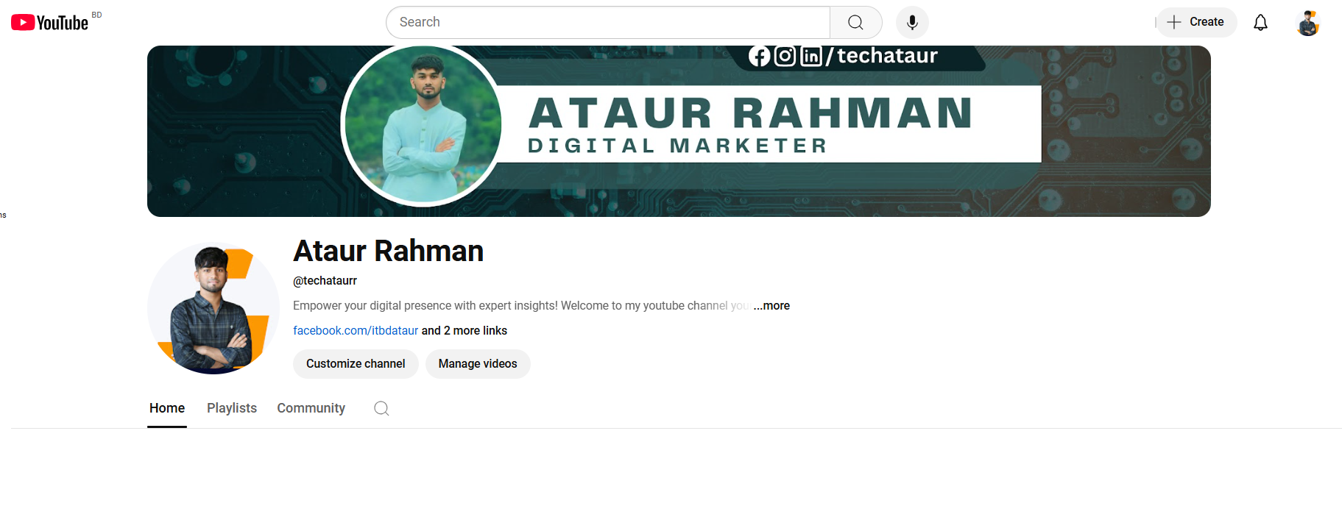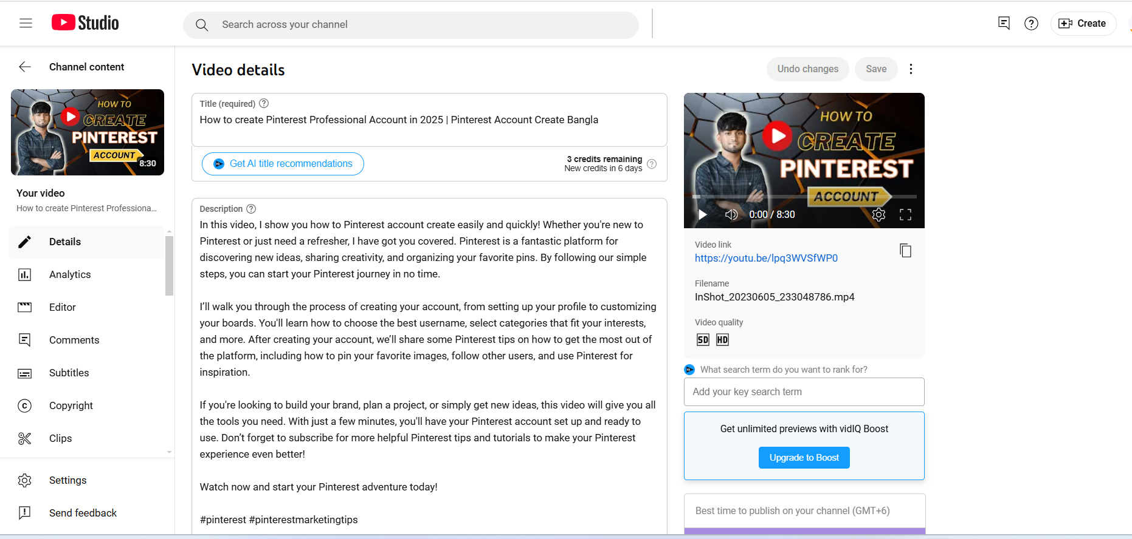

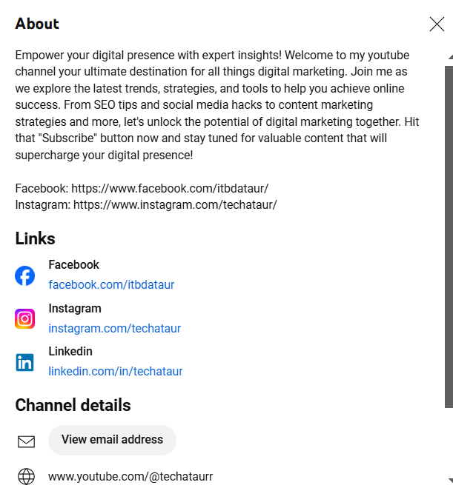

**Answer no. 3: Definition of Digital Marketing**

Digital marketing refers to the use of digital channels, platforms, and technologies to promote products or services to a target audience. These channels include websites, social media, email, search engines, mobile apps, and other online platforms. Digital marketing encompasses various strategies like search engine optimization (SEO), content marketing, pay-per-click advertising (PPC), social media marketing (SMM), email marketing, and affiliate marketing.

**Advantages of Digital Marketing**

**Global Reach**

* Businesses can reach a worldwide audience without geographical limitations.

**Cost-Effective**

* Digital marketing is more affordable compared to traditional marketing channels like TV, radio, or print. Small businesses can implement strategies like social media ads and email campaigns with minimal budgets.

**Targeted Audience**

* Digital marketing allows precise targeting through demographics, interests, behaviors, and location, ensuring that campaigns reach the right audience.

**Measurable Results**

* Tools like Google Analytics, Facebook Insights, and HubSpot provide real-time metrics, enabling businesses to track the success of campaigns and optimize them accordingly.

**Personalization**

* Marketers can tailor content and ads based on user preferences and behavior, increasing engagement and conversion rates.

**Flexibility**

* Businesses can easily adjust strategies or budgets in real time, adapting to market changes.

**Higher Engagement**

* Interactive content such as polls, quizzes, and videos drives audience engagement and fosters brand loyalty.

**Better ROI**

* With its measurable nature, digital marketing often delivers a higher return on investment compared to traditional methods.

**Mobile Accessibility**

* With the rise in smartphone usage, digital marketing effectively reaches users on their mobile devices.

**Increased Brand Awareness**

* Social media and online presence boost a business’s visibility and brand recognition.

**Disadvantages of Digital Marketing**

**Intense Competition**

* With so many businesses using digital marketing, standing out requires unique and creative strategies.

**Overload of Information**

* Consumers are bombarded with ads and content daily, leading to potential ad fatigue or banner blindness.

**Technical Issues**

* Businesses need to maintain websites, landing pages, and digital platforms, which may involve technical challenges.

**Privacy Concerns**

* Collecting and storing user data can raise privacy issues, and mishandling data may damage a brand's reputation.

**Dependence on Technology**

* Digital marketing relies heavily on technology, and issues like downtime, server errors, or platform changes can disrupt campaigns.

**Learning Curve**

* Understanding and effectively implementing digital marketing tools and strategies require time and expertise.

**Ad Blockers**

* Many users install ad-blocking software, which can limit the reach of paid ads.

**Frequent Algorithm Changes**

* Platforms like Google and Facebook regularly update algorithms, which can impact visibility and rankings.

**Risk of Negative Feedback**

* Online platforms allow customers to leave reviews and feedback publicly, which, if negative, can harm a brand’s image.

**Time-Consuming**

* Developing, implementing, and monitoring campaigns can be time-intensive, especially for smaller businesses with limited resources.

**Answer no.4: What Makes Content Engaging on Facebook?**

Engaging content on Facebook stands out and encourages users to interact. Here’s what makes content compelling and shareable:

#### 1. Visual Elements

* High-Quality Images: Posts with visually appealing images attract attention. Use bright, clear, and relevant visuals.
* Videos: Videos, especially short-form or live videos, get more engagement as they capture attention quickly.
* Memes and GIFs: Fun, relatable, or trending visual content often goes viral.

#### 2. Captivating Copy

* Catchy Headlines: Start with an interesting, bold, or emotional hook to grab attention.
* Ask Questions: Encourage your audience to comment or share opinions (e.g., “What’s your favorite travel destination?”).
* Call to Action (CTA): Include clear CTAs like “Share your thoughts!” or “Click to learn more.”

#### 3. Interactivity

* Polls and Quizzes: Facebook’s interactive features like polls, quizzes, and Q&A sessions boost user engagement.
* Contests and Giveaways: Encourage likes, shares, and comments by hosting contests with exciting rewards.
* Live Streaming: Real-time interactions during live streams foster community and excitement.

#### 4. Value and Relevance

* Educational Content: Tutorials, tips, and “how-to” posts provide value to your audience.
* Relatable Stories: Share stories that connect with your audience emotionally or resonate with their experiences.
* Trending Topics: Leverage current trends or hashtags to make your content timely and relevant.

#### 5. Consistency and Timing

* Post Regularly: Consistent posting keeps your audience engaged and expecting new content.
* Optimal Timing: Post when your audience is most active (use Facebook Insights to find peak times).

### **Importance of Facebook Marketing**

Facebook marketing plays a critical role in promoting businesses, building brand awareness, and driving sales. Here's why it's so essential:

#### **1. Vast User Base**

* With **over 2.9 billion active users**, Facebook offers unparalleled reach, making it a vital platform for businesses of all sizes.

#### **2. Cost-Effective Advertising**

* Facebook Ads allow businesses to create targeted campaigns with budgets as low as a few dollars. This makes it affordable for startups and small businesses.

#### **3. Precise Targeting**

* Facebook allows marketers to target specific audiences based on demographics, interests, behaviors, and location, ensuring campaigns reach the right people.

#### **4. Diverse Content Formats**

* Businesses can use images, videos, stories, live streams, and carousel ads to creatively present their message.

#### **5. Engagement and Relationship Building**

* Facebook fosters direct interaction between brands and customers, enabling businesses to build trust and loyalty.
* Features like **comments, likes, shares, and Messenger** create opportunities for engagement.

#### **6. Increased Website Traffic**

* Facebook posts and ads often drive traffic to a business’s website, boosting conversions and sales.

#### **7. Brand Awareness and Community Building**

* Regular posts, engaging content, and group interactions help increase visibility and foster a sense of community around a brand.

#### **8. Performance Insights**

* Facebook provides detailed analytics, allowing businesses to track the performance of posts and ads to optimize future strategies.

#### **9. Mobile-Friendly Platform**

* With the majority of users accessing Facebook on mobile devices, businesses can reach their audience anytime, anywhere.

#### **10. Retargeting Capabilities**

* Facebook’s **Pixel** feature helps businesses re-engage users who have visited their website or interacted with their content, increasing the chances of conversion.